1st Annual Buckhorn High School FCCLA Breast Cancer Walk
Tommy R. Ledbetter Stadium on October 18, 2014 at 9A.M
Registration Form:
Please fill out completely (one form per walker/runner)
Mail form to or drop off at: BHS attn. Whitney Webster 4123 Winchester Rd. New Market, AL 35761
First Name
Last Name
Address
City/State/Zip
Phone Email
Birthdate Age as of 10/18/14
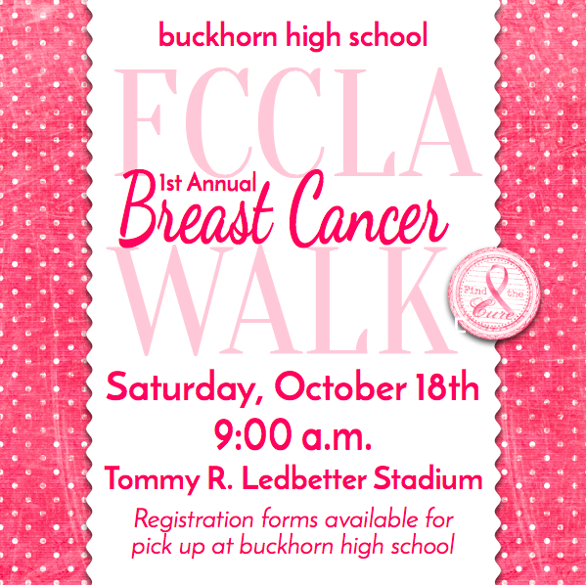
Male or Female
Event (Circle one):
Walk/Run
Donation
T-Shirt (Circle one):
S M L XL XXL XXXL
Entry Fee:
$25 when received by Oct. 15
$35 late registration on Oct.17 (shirts & sizes limited)

Total Enclosed:
Make check payable to BHS (BLUE AND BLACK INK ONLY & include phone #)
***The walk will occur rain or shine. We reserve the right to cancel under extreme circumstances. In this event, there will be no refunds, and your entry fee will be donated.
SIGNATURE
Parent/Guardian Signature (if under 18)

